AI Acceleration as a Service
Solution Architecture and AI Enablement Plan
Healthcare Payer | Two Validated POCs | AWS Reference Architecture
Editable technical source of truth
Prepared by Ravi Chillara
August 29, 2026
UC2, Intelligent Referral Matching and Routing
UC5, Claims Ingestion and Normalization

Table of Contents
Update the table of contents in Word.

Document Control
Field | Value
Purpose | Provide the technical source of truth for the solution strategy, POC architecture, production architecture, AI enablement plan, delivery model, and roadmap.
Audience | Executive sponsors, enterprise architects, security leaders, product owners, AI engineers, integration teams, and healthcare operations leaders.
POCs selected | UC2, Intelligent Referral Matching and Routing; UC5, Claims Ingestion and Normalization.
Detailed AI Enablement Plan | UC2, Intelligent Referral Matching and Routing.
POC implementation | One runnable FastAPI application with two workflow endpoints, synthetic data, external task instructions, deterministic services, claims knowledge, automated tests, and reproducible scenarios.
Editability | The Word document is editable. Diagram sources are delivered as Mermaid files. Presentation diagrams are designed as editable slide content.

1. Executive Summary
This plan uses two Phase One POCs. UC2 improves care access by reading a referral, finding valid providers, applying fixed payer rules, ranking the valid choices, explaining the result, and routing the referral. UC5 improves payer operations by parsing and checking an X12 837P claim, creating a common claim record, and helping staff investigate exceptions.
The two POCs cover different business areas. UC2 supports members and providers. UC5 supports claims operations. Together, they show that one governed platform can use AI, fixed rules, enterprise tools, approved knowledge, saved workflow state, audit records, and human review.
The supplied POC package makes the architecture concrete. It provides the /referrals/match and /claims/process FastAPI endpoints, synthetic referral and claims data, external task instructions, deterministic provider ranking and X12 processing, a grounded claims runbook, typed outputs, audit events, and six automated tests. Automated test execution passed all six tests. The current POCs use local deterministic implementations to test workflow contracts, fixed controls, task structure, tool boundaries, and exception paths. They do not call an LLM or Amazon Bedrock.
The design combines AI with fixed business rules. AI helps when the input is unclear. Systems of record provide trusted facts. Fixed rules enforce required checks and transaction controls. People review important exceptions. Task instructions, policies, tool contracts, knowledge, guardrails, and tests stay outside the model and runtime, so the client can replace those components later. AWS also describes agent patterns as reusable building blocks with control, monitoring, and audit.[1]

2. Engagement Scope and Objectives
The engagement covers five candidate payer use cases, a value-versus-lift evaluation, two implemented POCs, a shared logical architecture, an AWS production reference architecture, a detailed UC2 AI Enablement Plan, a twelve-week delivery plan, a delivery-team estimate, production-readiness criteria, and a sequenced roadmap.
The primary business objective is to validate useful payer workflows while establishing reusable enterprise capabilities. The primary technical objective is to prove that AI reasoning can be combined with deterministic healthcare processing, authoritative tool access, explicit state, human review, and operational controls.
Objective | Evidence in the proposed solution
Deliver practical POCs | UC2 and UC5 run as FastAPI endpoints with synthetic data and reproducible scenarios.
Demonstrate agentic patterns | UC2 interprets, searches, filters, ranks, explains, and routes. UC5 investigates, grounds, explains, and routes exceptions.
Preserve authoritative control | Provider facts come from a provider tool. Network filters execute before ranking. X12 parsing and validation remain deterministic.
Create reusable assets | The runtime externalizes tasks, knowledge, tool contracts, workflow state, audit, and evaluation behavior.
Define production readiness | The architecture addresses security, PHI controls, integration, reliability, observability, governance, and operating ownership.
Support future workflows | Shared patterns accelerate UC3 Scheduling, UC4 Specialist Network, and UC1 Procedure Readiness.

3. Requirements and Assumptions
The assignment requirements and the design assumptions are separated so that discovery can replace assumptions with verified client facts.
Category | Requirement or assumption
Known requirement | Evaluate all five use cases using value, technical lift, and business scope.
Known requirement | Select two to three workflows and provide working or simulated POCs.
Known requirement | Define a detailed production-readiness plan for one use case.
Known requirement | Provide solution architecture, sizing, security, scale, reliability, roadmap, and presentation materials.
Design assumption | The client is a representative United States healthcare payer.
Design assumption | Client systems, policies, transaction volumes, products, availability targets, and platform internals require discovery.
Design assumption | The POCs use synthetic data and mock enterprise interfaces.
Design assumption | AWS is the production hyperscaler reference. Amazon Bedrock is used when a managed model capability fits the client standard.
Design assumption | The logical architecture maps to the client’s selected agentic platform during discovery.
Design assumption | FHIR is used where supported. Proprietary APIs, X12, files, queues, and batch interfaces remain valid where required.

4. Business Context and Five Use Cases
The five use cases form two related value streams. The care-access stream combines specialist-network intelligence, referral matching, scheduling, and procedure readiness. The payer-operations stream applies intelligent exception handling to claims ingestion.
Use case | Business outcome | Primary architecture pattern | Portfolio role
UC1, Procedure Readiness for Scheduling | Identify clinical and administrative readiness conditions before scheduling. | Evidence collection, policy evaluation, deterministic readiness rules, and exception review. | Future payer-provider workflow.
UC2, Intelligent Referral Matching and Routing | Identify appropriate in-network specialists and route referrals with evidence. | Document understanding, authoritative search, deterministic filters, ranking, and explanation. | POC 1 and detailed enablement plan.
UC3, Automated Scheduling and Admin Assistant | Improve member self-service and administrative coordination. | Conversation, workflow state, provider context, slot discovery, confirmation, and transaction control. | Next care-access workflow.
UC4, Specialist Network Integration | Create trusted specialist and network context across payer sources. | Entity resolution, taxonomy, provenance, network-product mapping, and data-quality workflow. | Strategic data foundation.
UC5, Claims Ingestion and Normalization | Normalize claim intake and improve exception investigation. | Deterministic X12 pipeline, canonical data, grounded investigation, and operational routing. | POC 2.

5. Value-Versus-Lift Evaluation
Business value is scored across payer ownership, operational impact, experience impact, and strategic reuse. Implementation lift is scored across integration, data, AI workflow, and production complexity. A higher lift score represents greater effort. Portfolio leverage reflects POC feasibility, demonstration impact, reusable capability creation, and future-workflow acceleration.
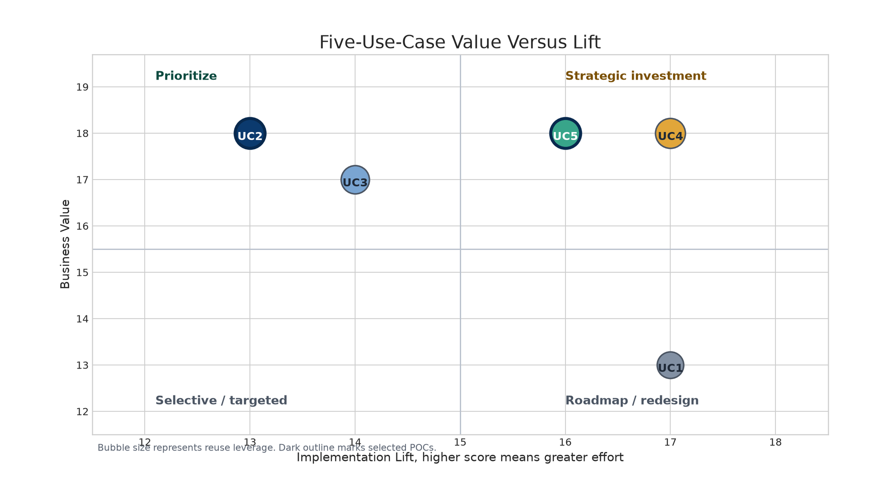
Five-use-case value-versus-lift view
Use case | Value /20 | Lift /20 | Portfolio leverage /20 | Value minus lift | Recommendation
UC1, Procedure Readiness | 13 | 17 | 14 | -4 | Roadmap and cross-enterprise candidate.
UC2, Referral Matching | 18 | 13 | 19 | 5 | Select as POC 1 and detailed enablement plan.
UC3, Scheduling Assistant | 17 | 14 | 18 | 3 | Select as the next care-access workflow.
UC4, Specialist Network | 18 | 17 | 18 | 1 | Treat as the strategic provider-data foundation.
UC5, Claims Ingestion | 18 | 16 | 18 | 2 | Select as POC 2.

UC2 has the strongest value-versus-lift profile and the highest portfolio leverage. UC5 has higher production lift, but its focused synthetic POC has strong feasibility and demonstration value. UC3 also has strong value, but its most important production outcome depends on external provider scheduling connectivity. UC4 has broad strategic value, but its production scope includes identity resolution, source reconciliation, product participation, and provider-data governance. UC1 has meaningful value, but complete readiness also depends on provider-side clinical and operational ownership.

6. POC Selection and Value Story
The selected POC pair provides a clear executive story. UC2 demonstrates how the platform can improve access to appropriate care. UC5 demonstrates how the same platform can improve a core payer operational process.
Selected POC | Business story | Agentic behavior | Deterministic boundary
UC2, Referral Matching | Help a member or coordinator identify an appropriate valid specialist and route the referral. | Interpret clinical text, identify specialty, explain ranking, detect ambiguity, and coordinate tools. | Provider facts, network status, accepting-new-patient status, and hard filters remain authoritative and deterministic.
UC5, Claims Ingestion | Normalize a claim and help operations investigate exceptions. | Explain validator output, collect evidence, identify likely root cause, and recommend a queue. | X12 parsing, required-field validation, canonical mapping, and the successful claims path remain deterministic.

The selection is based on breadth and complementarity rather than two similar demonstrations. UC2 shows “understand, match, explain, and route.” UC5 shows “normalize, investigate, explain, and resolve.”

7. AI-Native Architecture Principles
Principle | Design application
Deterministic core with AI reasoning | Systems of record and deterministic services establish facts and enforce hard requirements. AI interprets ambiguous content and supports complex investigation.
Externalized durable task definitions | Instructions, policies, knowledge, allowed tools, output contracts, guardrails, and evaluation cases remain versioned outside the model.
Controlled enterprise tools | Agents call typed interfaces for provider, member, benefit, authorization, scheduling, and claims information.
Grounded reasoning | Explanations use approved policy, taxonomy, runbook, and source-system evidence.
Explicit workflow state | Long-running cases, retries, approvals, exceptions, and final disposition persist outside the model context.
Bounded autonomy | The runtime limits allowed actions, validates outputs, and routes configured cases to human review.
Replaceable model and runtime | Model access and orchestration frameworks remain implementation choices behind stable contracts.
Reusable evaluation suites | Versioned normal, exception, ambiguity, and failure scenarios support regression testing.

8. Common Patterns and Reuse Story
All five use cases use six common patterns. Each POC therefore creates parts that can support the next workflow.
Reusable pattern | UC1 | UC2 | UC3 | UC4 | UC5
Deterministic core plus AI reasoning | Readiness rules and explanations. | Hard filters before ranking. | Booking and confirmation controls. | Identity and network validations. | X12 pipeline and exception reasoning.
Extraction, normalization, and entity resolution | Procedure evidence model. | Referral case model. | Intent and appointment context. | Trusted specialist profile. | Canonical claim model.
Enterprise tool and API orchestration | Authorization, provider, facility, scheduling. | Member, benefit, provider, network, authorization. | Provider, schedule, communication. | Directory, contracting, credentialing. | Validator, logs, claims platform, queues.
Grounded knowledge and RAG | Readiness and authorization policy. | Specialty and routing policy. | Administrative guidance. | Taxonomy and data-quality rules. | Companion guides and runbooks.
Workflow state and exception management | Missing prerequisite tracking. | Ambiguity and routing review. | Confirmation, failure, and escalation. | Source conflict resolution. | Error case, replay, and resolution.
Explainability and human review | Blocker evidence. | Recommendation evidence. | Appointment and escalation explanation. | Source and quality explanation. | Root-cause evidence and operational route.

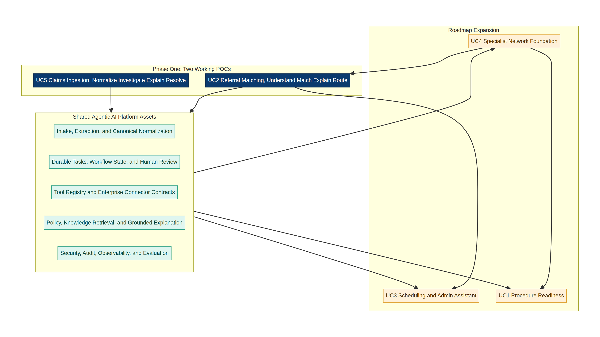
Shared capability reuse across the portfolio
The reuse story begins with the two POCs. UC2 establishes referral intake, specialty understanding, authoritative provider search, deterministic filtering, ranking, explanation, audit, and human review. UC5 establishes canonical transaction processing, deterministic validation, grounded exception investigation, correlation, and routing. UC4 later strengthens trusted provider and network data. UC3 reuses the UC2 context and connector patterns for scheduling. UC1 reuses policy, document, authorization, provider, workflow, and review services for procedure readiness.

9. Target Logical Architecture
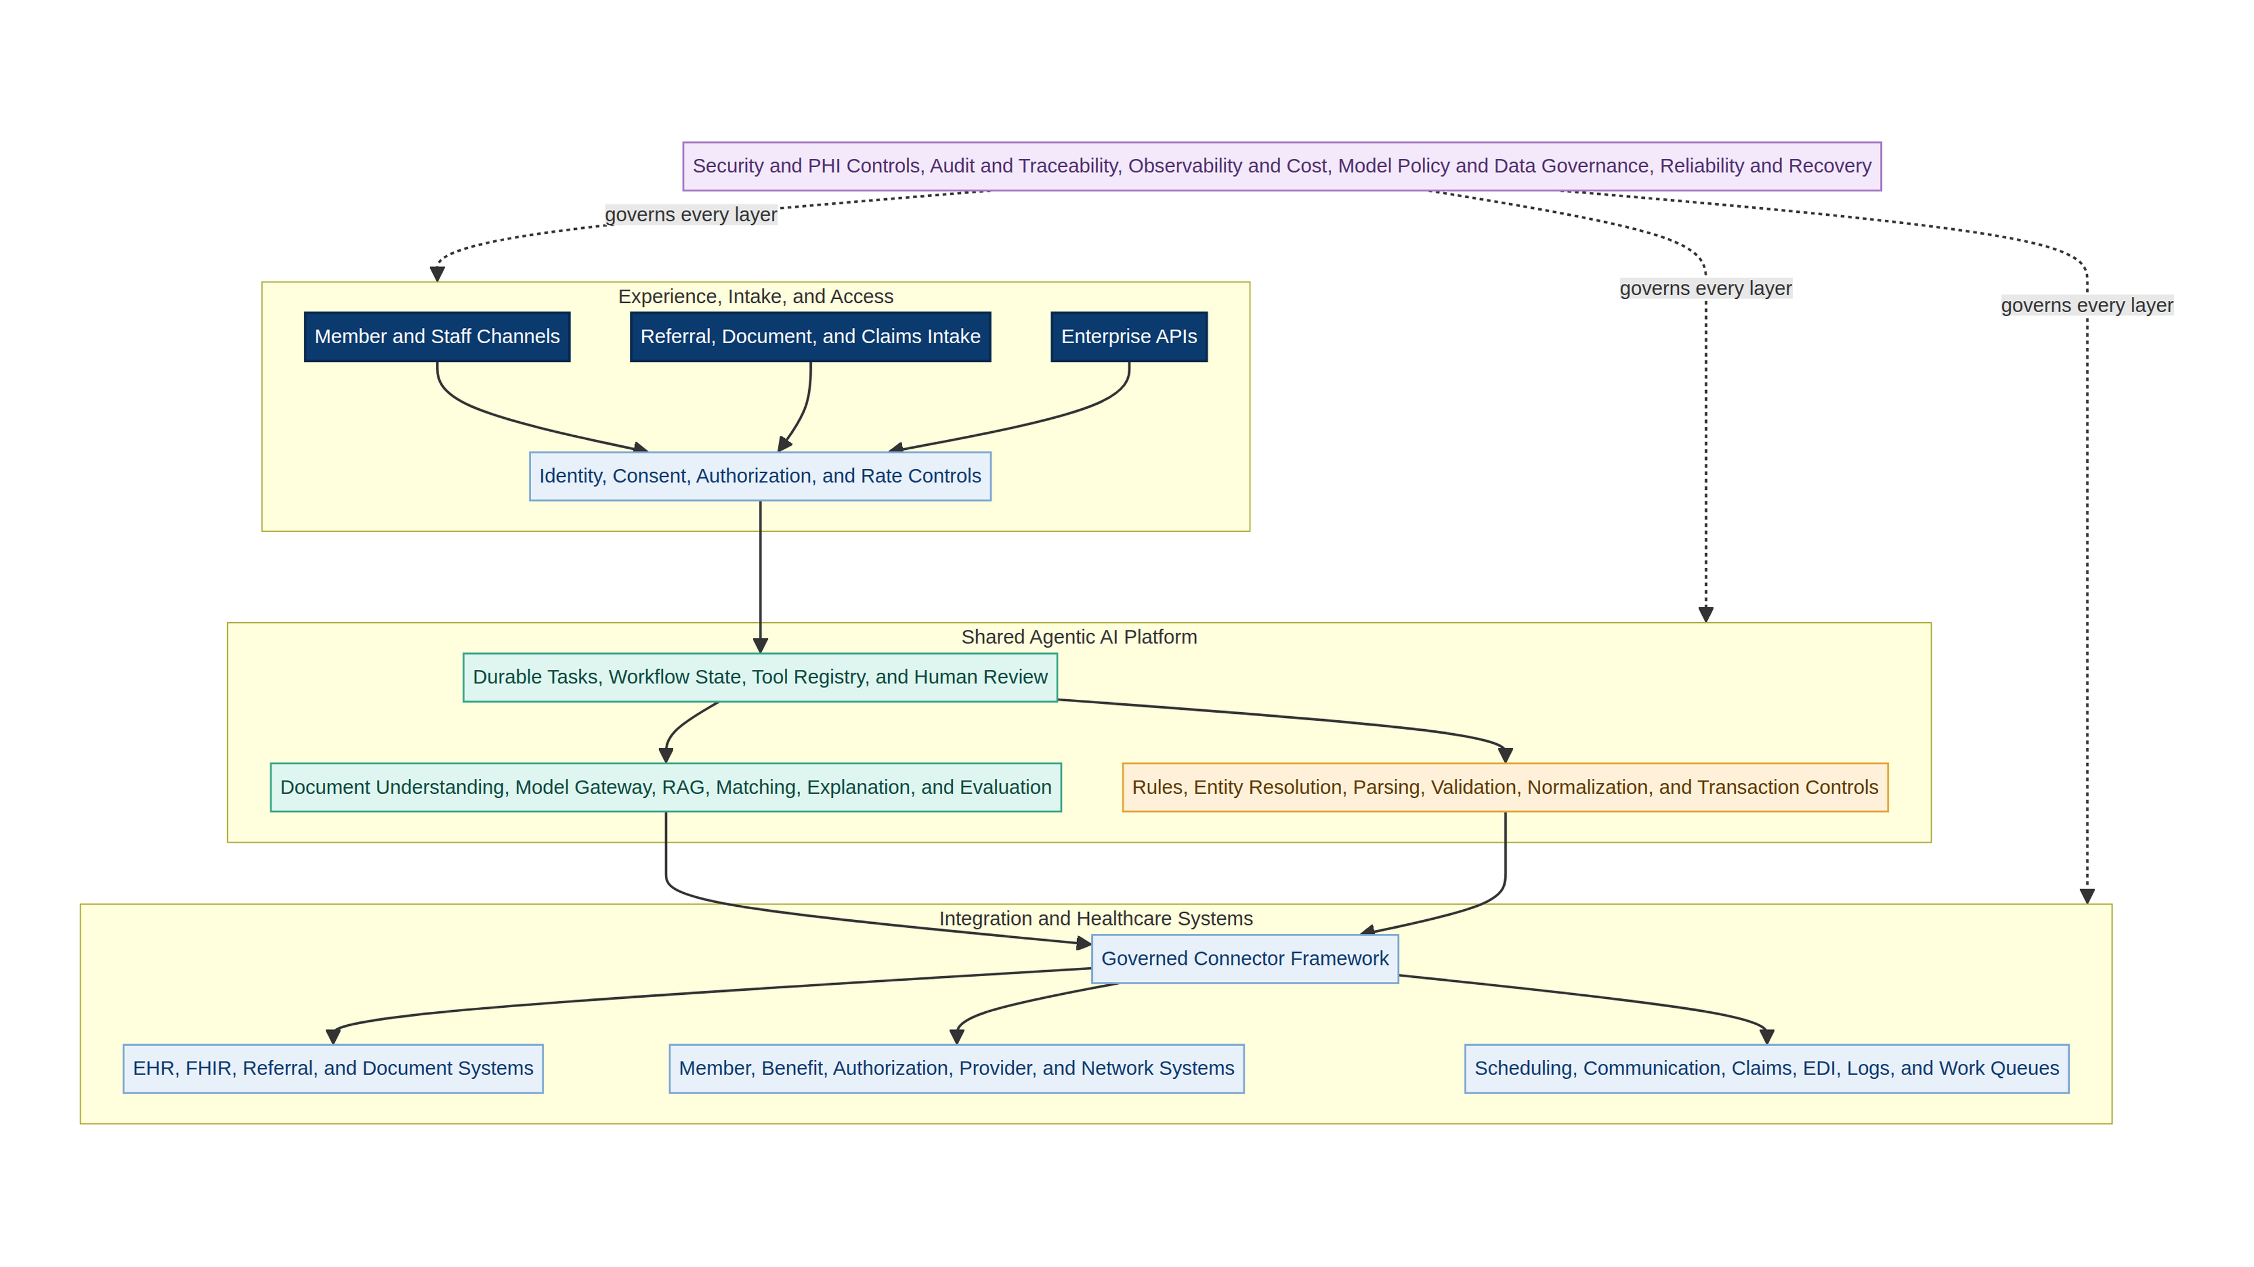
Target logical architecture
The design begins with member, staff, document, claims, and enterprise API channels. The access layer checks identity, consent, permission, requests, and traffic limits. The shared platform stores task instructions and workflow state. It also provides tool contracts, policy checks, human review, document reading, model access, knowledge search, ranking, explanation, parsing, validation, normalization, and transaction controls.
The connector layer keeps workflow logic separate from enterprise systems. It connects to FHIR, clinical records, referrals, enrollment, benefits, authorization, provider, network, scheduling, communications, claims, EDI, logs, and work queues. Security, audit, monitoring, cost control, governance, reliability, and recovery apply to every layer.

10. Implemented POC Runtime
The supplied runtime is one lightweight FastAPI application that hosts both workflows. It uses synthetic data and local deterministic implementations, so demonstrations do not require cloud credentials, an LLM call, or an Amazon Bedrock call. The runtime is intentionally replaceable. A production model gateway, such as an approved Bedrock-based gateway, can replace the local implementation while preserving the task and service contracts.
Runtime element | Implemented evidence | Production evolution
API surface | GET /demo/referrals, GET /demo/claims, POST /referrals/match, and POST /claims/process. | API Gateway, enterprise identity, request policy, rate control, and service-level monitoring.
Durable tasks | Referral and claims instructions stored under app/tasks. | Versioned task registry with approval, deployment, rollback, and ownership controls.
Reasoning adapter | Local deterministic referral interpretation and claims exception reasoning. | Model gateway using approved Amazon Bedrock models or the client model service.
Enterprise tools | Synthetic provider data, deterministic claim parser, validator, normalizer, and runbook access. | Typed connectors to payer systems, FHIR APIs, EDI services, logs, and work queues.
Knowledge | claims_runbook.md provides grounded entries for known errors. | Curated, approved, versioned knowledge with retrieval quality controls and citations.
State and audit | Typed response objects include status, evidence, confidence, review flags, and audit events. | Persistent workflow store, trace correlation, immutable audit history, and operational dashboards.
Evaluation | Six automated tests cover normal, guardrail, human-review, accepted claim, known error, and downstream error paths. | Golden datasets, tool-mock suites, security tests, load tests, and release gates.

11. UC2 Detailed Solution, Intelligent Referral Matching and Routing

11.1 Objective and POC Boundary
UC2 identifies the appropriate specialist need from referral text, retrieves candidates from an authoritative provider source, applies hard payer requirements, ranks only valid candidates, explains the result, and routes the referral or sends it to human review.
The POC uses synthetic referral and provider data. It does not connect to a production EHR, enrollment platform, provider directory, network-contracting platform, authorization system, or routing queue. It proves the task structure, API contracts, deterministic filter order, ranking approach, explanation structure, review logic, and audit output.

11.2 Implemented Workflow
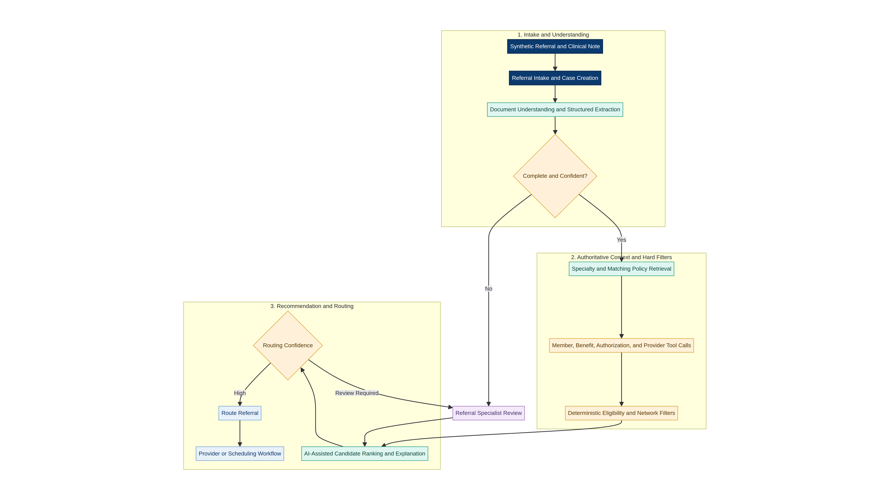
UC2 referral matching workflow
The /referrals/match endpoint receives a referral identifier, member identifier, referral text, ZIP code, product, and preferred language. The implementation interprets clinical terms into a controlled specialty and focus. It retrieves candidates only from the provider dataset. Product participation and new-patient status are enforced before ranking.
The deterministic ranking score uses a weighted combination of subspecialty relevance, quality, and distance. The current POC weights are 55 percent clinical and subspecialty relevance, 30 percent normalized quality, and 15 percent distance. These values are implementation settings for the POC and will require business validation before production.

11.3 Validated Scenarios
Scenario | Input and control | Validated output
Normal referral | Synthetic knee referral for a PPO member. | Status ROUTED. Provider P100, Capital Ortho Sports Medicine, ranks first with match score 0.951. Human review is false.
Network guardrail | A clinically strong provider participates in HMO but not the member’s PPO product. | Provider P101 is placed in excluded candidates before ranking, with reason Not in member product PPO.
Ambiguous referral | Referral supports both Orthopedic Surgery and Neurology. | Status REVIEW_REQUIRED, confidence 0.58, no ranked candidates, and human review is true.

The normal output also records the rules applied, excluded candidates, ranked candidates, explanation, confidence, review state, and audit history. The result demonstrates that the model or reasoning component does not invent provider facts or override network controls.

11.4 Production Integration and Healthcare Data
HL7 FHIR R4 ServiceRequest can represent a referral or request for consultation and can carry the clinical reason and supporting context.[5] Representative resources for the production workflow include Patient, ServiceRequest, Condition, Observation, DiagnosticReport, DocumentReference, Practitioner, PractitionerRole, Organization, Location, HealthcareService, Coverage, and Task.
CMS identifies FHIR R4 and several Da Vinci implementation guides as important payer interoperability standards. Plan Net supports query access to provider-network information. CRD, DTR, and PAS support coverage requirements, documentation, and prior-authorization exchange patterns.[7]
Integration | POC | Production target
Referral source | Synthetic JSON and text. | EHR, care-management, portal, fax-document, or FHIR ServiceRequest connector.
Member and coverage | Request fields and mock context. | Enrollment, eligibility, benefit, and product APIs.
Provider and network | Synthetic provider JSON. | Provider directory plus contracting, network-product, specialty, location, quality, and access sources.
Prior authorization | Architectural placeholder. | Utilization-management or prior-authorization interface, with FHIR or X12 mapping where applicable.
Routing destination | Response status. | Care coordinator queue, provider destination, referral platform, or scheduling workflow.
Human review | Response flag. | Work queue with owner, service level, evidence, disposition, and audit.

11.5 UC2 Success Measures
Measure | POC acceptance | Production measure
Specialty interpretation | Expected specialty on the fixed test set. | Accuracy by referral type and source.
Network compliance | Invalid product participation never appears in ranked results. | Percentage of routed referrals with verified product participation.
Ranking quality | Expected top candidate on known cases. | Business and reviewer acceptance, outcome analysis, and fairness review.
Routing accuracy | Expected route or review state. | Correct destination rate and avoidable reroute rate.
Explanation completeness | Facts, rules, score, confidence, and next action present. | Reviewer usefulness and evidence verification rate.
Operational performance | Repeatable demo response. | Latency, tool success, exception rate, review time, throughput, and cost.

12. UC5 Detailed Solution, Claims Ingestion and Normalization

12.1 Objective and Architecture Boundary
UC5 receives a representative X12 837P claim, deterministically parses and validates the transaction, creates a canonical claim for valid input, and uses AI-assisted investigation for exceptions. The use case improves intake and operations. It does not perform adjudication or decide whether a claim should be paid.
X12 identifies the 837 transaction set as the healthcare claim format used to submit and transfer professional, institutional, and dental claims and encounters to payers.[8] This supports the design decision to keep transaction parsing and syntax validation deterministic.

12.2 Implemented Workflow
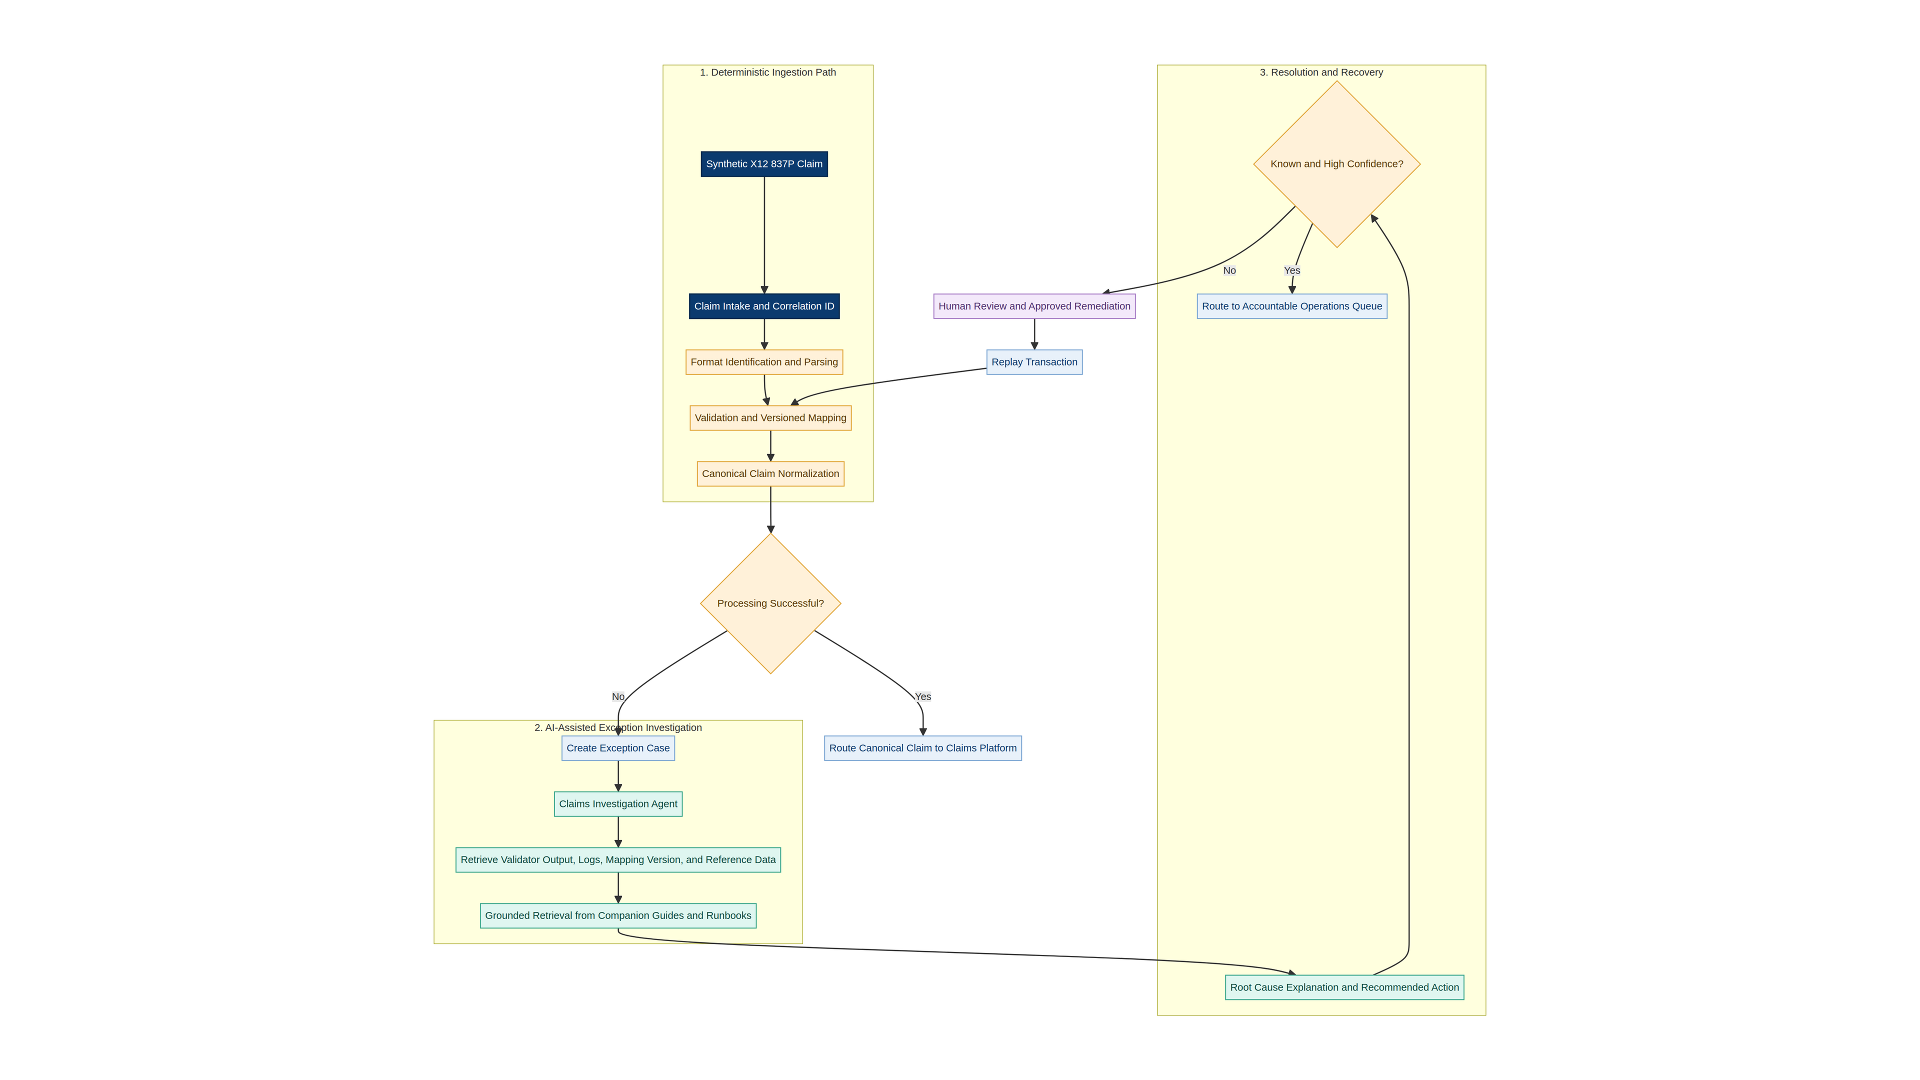
UC5 claims ingestion workflow
The /claims/process endpoint receives a claim identifier, an X12 string, and an optional simulated downstream error. The parser extracts member identifier, rendering-provider NPI, claim number, total charge, diagnosis code, procedure code, and line charge. Deterministic validation checks required values. Valid input is transformed into a canonical JSON object.
The successful path bypasses investigation. The exception path collects validator output or downstream error evidence and compares it with the approved runbook. The result contains a root-cause explanation, evidence, recommended route, confidence, grounding source, human-review flag, and audit history.

12.3 Validated Scenarios
Scenario | Control | Validated output
Valid 837P | Complete representative professional claim. | Status ACCEPTED, canonical claim JSON created, investigation is null, and the audit states that successful processing bypassed investigation.
Missing rendering-provider NPI | Required provider value omitted. | Status EXCEPTION, error VAL-RENDERING-NPI, grounded explanation, route to EDI Operations or Trading Partner Correction, confidence 0.98.
MAP-204 downstream failure | Valid claim plus simulated diagnosis-pointer mapping failure. | Status DOWNSTREAM_EXCEPTION, canonical claim retained, runbook evidence identified, route to Claims Integration Support, confidence 0.94.

12.4 Production Integration
Integration | POC | Production target
Claim intake | Synthetic X12 837P string. | Clearinghouse, EDI gateway, secure file, message, or API.
Validation | Focused required-field checks. | Licensed X12 validation, implementation-guide validation, trading-partner rules, duplicate and control-number handling.
Mapping | Focused canonical JSON. | Versioned 837P, 837I, 837D, FHIR Claim, and partner mappings into an enterprise canonical model.
Reference data | Synthetic identifiers. | Member, provider, code set, product, trading-partner, and configuration services.
Investigation | Runbook lookup and simulated log error. | Correlated gateway, transformation, application, database, and claims-platform evidence.
Routing and replay | Response route. | Operations queues, authorized correction workflow, replay service, and full audit.

FHIR can provide another interoperability representation where it fits the client architecture. FHIR Claim represents claim-related information, while ExplanationOfBenefit represents the outcome of claim processing and should remain distinct from an incoming claim.[7]

13. Common Data and Integration Architecture
The integration architecture uses typed contracts and canonical context models. Workflow tasks consume stable contracts rather than direct vendor-specific interfaces. Adapters map each client system to the shared contract.
Shared contract | Representative data | Consumers
Member context | Identity, coverage, product, eligibility, preferences, and consent. | UC1, UC2, and UC3.
Referral context | Referral reason, clinical evidence, requested service, specialty, source, and status. | UC1, UC2, and UC3.
Provider context | Identity, specialty, location, organization, network-product participation, quality, access, and provenance. | UC1, UC2, UC3, and UC4.
Policy context | Coverage requirements, specialty taxonomy, routing rules, documentation requirements, and effective dates. | UC1, UC2, UC3, and UC5.
Canonical claim | Member, provider, claim, diagnosis, procedure, service-line, amount, and source metadata. | UC5 and downstream claims operations.
Case and evidence | Workflow status, tool evidence, rule results, confidence, human actions, and disposition. | All five use cases.

The connector framework should support synchronous APIs, asynchronous events, files, X12 transactions, batch exchange, and document ingestion. Each connector contract should define authentication, authorization, request and response schemas, timeout, retry, idempotency, error taxonomy, service-level target, audit fields, and data classification.

14. AWS Production Reference Architecture
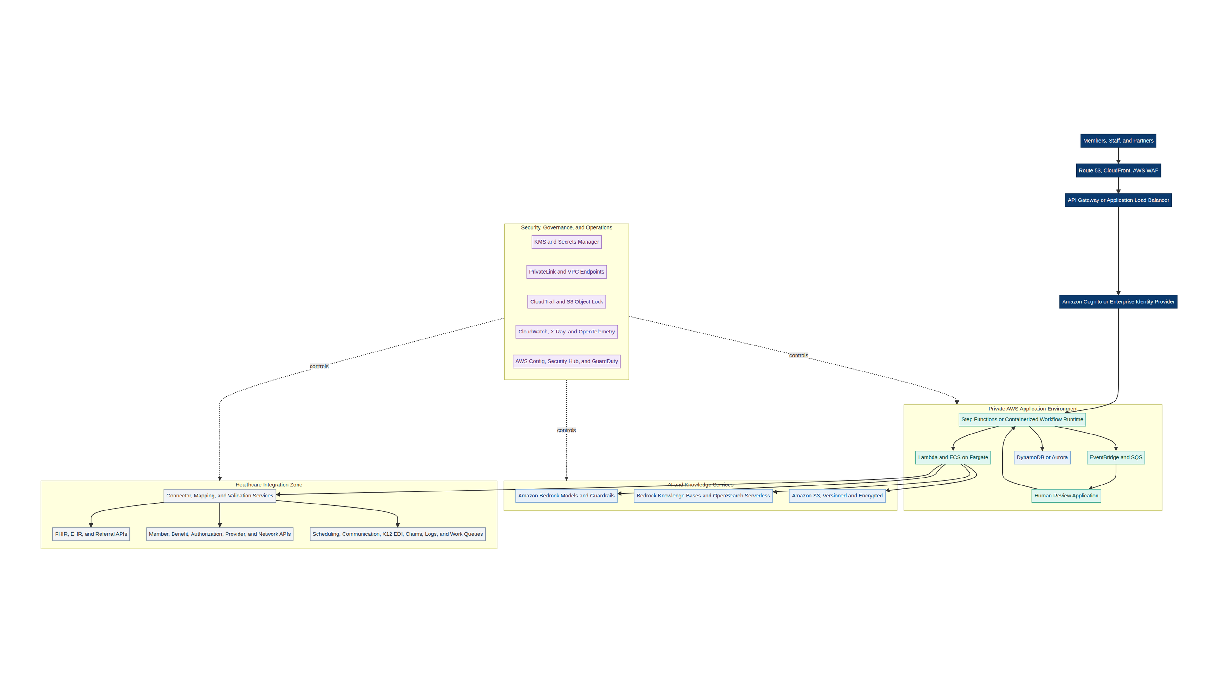
AWS production reference architecture
The AWS mapping is a reference implementation rather than a mandatory service list. The logical capabilities remain portable. AWS Step Functions can coordinate explicit workflows and integrates with Amazon Bedrock for model tasks.[4] Containerized services or Lambda can implement deterministic tools, adapters, and workflow activities. SQS and EventBridge support asynchronous work and decoupling. DynamoDB or Aurora can store workflow and business state according to transaction needs.
Amazon Bedrock provides managed model access and guardrails behind an application model gateway. Bedrock Knowledge Bases and OpenSearch Serverless can support approved retrieval patterns. S3 stores source documents, large payloads, evaluation assets, and audit artifacts. AWS guidance places security, guardrails, observability, private networking, identity, encryption, and governance across the complete healthcare generative AI stack.[2] [3]
Logical capability | Reference AWS mapping | Selection consideration
Edge and API | Route 53, CloudFront, AWS WAF, API Gateway, or Application Load Balancer. | Channel type, threat model, latency, and enterprise standards.
Identity | Cognito federation or enterprise identity provider. | Workforce versus member identity, consent, and role model.
Workflow runtime | Step Functions, ECS on Fargate, Lambda, or an approved agent runtime. | Long-running state, portability, language, concurrency, and operating model.
Model gateway | Amazon Bedrock behind an application abstraction. | Model approval, region, privacy, latency, quality, cost, and fallback.
Knowledge | S3, Bedrock Knowledge Bases, and OpenSearch Serverless. | Search quality, citation needs, document lifecycle, and tenancy.
State | DynamoDB or Aurora PostgreSQL. | Access pattern, transaction integrity, query needs, and client standards.
Events and queues | EventBridge, SQS, and dead-letter queues. | Delivery semantics, replay, ordering, and operational ownership.
Security and audit | IAM, KMS, Secrets Manager, PrivateLink, CloudTrail, and S3 Object Lock. | Data classification, least privilege, retention, and investigation needs.
Operations | CloudWatch, X-Ray, OpenTelemetry, Config, Security Hub, and GuardDuty. | Enterprise observability, compliance, threat detection, and support integration.

15. Security, Privacy, and AI Governance
AWS uses a shared-responsibility model. The client remains responsible for data classification, configuration, access, workload controls, legal obligations, and operating processes.[2] A healthcare production environment should use approved services, execute the required agreements, and complete client legal, privacy, risk, and compliance review.
Control domain | Required design
Identity and access | Workload identity, user identity, least privilege, role separation, time-bound access, and tool-level authorization.
PHI protection | Data minimization, encryption in transit and at rest, approved model endpoints, private network paths, secure logging, and retention controls.
Prompt and tool security | Input validation, instruction hierarchy, prompt-injection defenses, tool allowlists, parameter validation, and output schemas.
Grounding | Approved sources, version and effective date, citation, retrieval-quality evaluation, and blocking or review thresholds.
Model governance | Approved models, documented intended use, evaluation evidence, change control, fallback, monitoring, and retirement process.
Audit | Identity, case, correlation ID, input reference, model version, prompt or task version, tool calls, rules, evidence, human action, and final disposition.
Human oversight | Defined review triggers, approved reviewer roles, service levels, disposition codes, and escalation paths.
Data governance | Ownership, quality, provenance, retention, correction, access review, and source-system accountability.

16. Scaling, Reliability, and Observability
The platform persists workflow state outside the model. Every case receives a correlation identifier that connects channel activity, workflow states, tool calls, model calls, evidence, review actions, and outcome. Asynchronous workloads use idempotency keys, retries with bounded backoff, dead-letter queues, replay, and explicit terminal states.
Successful claim transactions remain on the deterministic path and avoid model calls. This design protects throughput, latency, cost, and transaction integrity. AI services scale according to exception volume rather than total claims volume.
Reliability concern | Architecture response
Duplicate input | Idempotency keys, transaction control numbers, duplicate detection, and safe replay.
Tool timeout | Per-tool timeout, retry policy, circuit breaker, cached reference data where valid, and exception state.
Model failure | Retry for transient failure, approved fallback model, deterministic fallback, or human review.
Low confidence | Review threshold, evidence display, and no consequential automatic action.
Partial workflow failure | Persistent checkpoints, compensation logic, and resumable state.
Data-source conflict | Provenance, effective dates, precedence rules, and human data-quality review.
Traffic spike | Queue-based buffering, horizontal scaling, backpressure, rate limits, and workload isolation.
Regional disruption | Client-defined recovery point and recovery time objectives, replicated durable state, backup, and tested recovery procedure.

Observability should cover business outcomes, system health, model behavior, tool behavior, security signals, and cost. Core metrics include workflow volume, state duration, exception rate, human-review rate, tool success, tool latency, model latency, grounded-response rate, guardrail interventions, token usage, cost per case, and final disposition.

17. Explainability and Human Review
Explanations should show the answer, evidence, rules, confidence, and next action. They should not expose internal chain-of-thought. The platform records a concise reasoning summary and structured evidence.
Review trigger | UC2 response | UC5 response
Low confidence | Route to referral specialist before provider matching or routing. | Route to claims subject-matter review.
Ambiguous interpretation | Show candidate specialties and source referral evidence. | Show plausible failure causes and observed system evidence.
Conflicting source facts | Show provider-data sources and apply ownership rules. | Show mapping, reference-data, and log conflict.
Material correction | Authorized staff approve a referral or source-data change. | Authorized staff approve configuration or data correction and replay.
Unknown pattern | Create a review case and capture disposition for future evaluation. | Create a review case and optionally add an approved runbook entry.

18. UC2 AI Enablement Plan
UC2 is the selected production-readiness use case because it exercises the broadest common platform capabilities. The enablement plan moves from the synthetic FastAPI implementation to a production payer workflow.
Area | Current POC | Production readiness action | Exit evidence
Referral intake | Synthetic referral JSON and text. | Validate source systems, document quality, referral identifiers, and FHIR or API mappings. | Approved source-to-case mapping and test data.
Member context | Request fields. | Connect enrollment, eligibility, benefit, and product services. | Signed interface contract and verified response behavior.
Provider and network | Synthetic provider JSON. | Establish provider identity, specialty, location, product participation, accepting status, quality, access, and provenance. | Data-quality baseline and authoritative ownership model.
Prior authorization | Architectural placeholder. | Connect utilization-management and authorization status. Validate CRD, DTR, PAS, X12, or proprietary interfaces. | Approved interface and status taxonomy.
Policy and knowledge | External task instructions and controlled POC logic. | Curate specialty taxonomy, routing policies, documentation, source references, owners, versions, and effective dates. | Approved knowledge set and retrieval evaluation.
Workflow state | Endpoint response and audit list. | Implement persistent case state, queue integration, retry, timeout, and escalation. | Recovery and state-transition tests.
Human review | Boolean review flag. | Implement referral-specialist queue, evidence view, disposition, ownership, and service level. | Operational runbook and reviewer acceptance.
Model gateway | Local deterministic reasoning adapter. | Introduce approved model gateway, structured outputs, guardrails, fallback, monitoring, and cost controls. | Model evaluation and release approval.
Security | Synthetic data only. | Complete PHI, privacy, IAM, network, encryption, logging, retention, and threat review. | Security and privacy approval.
Evaluation | Three automated UC2 tests. | Build representative golden dataset, adversarial tests, tool-failure tests, fairness review, and regression gates. | Agreed thresholds and release report.
Operations | Reproducible local demo. | Define monitoring, support ownership, incident response, model and policy change process, and rollback. | Production support readiness review.

19. Sizing and Delivery Model
The Phase One team is estimated at approximately 4.45 to 5.80 full-time-equivalent capacity across twelve weeks. Roles can be fractional, and one person may cover more than one role. The estimate excludes production integration teams that own client systems.
Role | Representative capacity | Primary responsibility
Solution Architect | 0.75 FTE | Architecture, client decisions, integration contracts, security alignment, and technical narrative.
AI Engineer | 1.0 to 1.5 FTE | Task definitions, model gateway, structured output, retrieval, evaluation, and POC behavior.
Backend and API Engineer | 1.0 FTE | FastAPI services, workflow state, tools, mock integrations, and deployment automation.
Healthcare SME and Product Analyst | 0.5 to 0.75 FTE | Workflow validation, taxonomy, business rules, demonstration scripts, and acceptance.
QA and Evaluation Engineer | 0.5 to 0.75 FTE | Automated tests, golden datasets, failure scenarios, and release evidence.
Security Architect | 0.2 to 0.3 FTE | Data classification, identity, threat controls, architecture review, and production criteria.
Data and Integration Engineer | 0.5 to 0.75 FTE | FHIR, X12, provider data, canonical models, and connector specifications.

Production sizing requires verified transaction volumes, concurrency, document sizes, model-call rates, exception rates, retention, availability targets, recovery targets, integration service levels, and enterprise support standards.

20. Twelve-Week Delivery Plan
Weeks | Focus | Deliverables and decision gates
1 to 2 | Discovery and validation | Confirm scope, business owners, system inventory, assumptions, success measures, security constraints, synthetic data, and production dependency risks.
3 to 4 | Architecture and POC design | Approve logical architecture, task definitions, tool contracts, canonical models, evaluation cases, user experience, POC backlog, and demo scripts.
5 to 6 | Shared runtime and UC2 build | Implement runtime services, referral workflow, mock payer tools, deterministic filters, explanation, human review, audit, and automated tests.
7 to 8 | UC5 build and integration | Implement X12 sample pipeline, canonical claim, runbook retrieval, exception investigation, routing, audit, and automated tests.
9 to 10 | Evaluation and stakeholder validation | Run normal, exception, ambiguity, missing-data, tool-failure, and security scenarios. Refine architecture and operating assumptions.
11 to 12 | Production plan and executive close | Complete UC2 enablement plan, sizing, roadmap, production-readiness criteria, final architecture document, editable deck, and decision package.

21. Evaluation and Success Measures
The evaluation program should measure deterministic correctness, model quality, workflow effectiveness, operational value, safety, and cost. The current POCs provide a starting regression suite, not a production-quality benchmark.
Evaluation area | Representative checks
Deterministic correctness | Network exclusion, new-patient filter, X12 parsing, required-field validation, canonical mapping, and routing rules.
AI task quality | Specialty interpretation, ambiguity detection, explanation quality, root-cause accuracy, and grounded evidence.
Tool correctness | Correct tool selection, valid parameters, response-schema handling, timeout behavior, and no unsupported tool calls.
Workflow reliability | State transition, retry, duplicate handling, review escalation, replay, timeout, and recovery.
Safety and governance | Prompt injection, data leakage, unsupported claims, ungrounded explanation, unauthorized action, and audit completeness.
Business outcome | Routing accuracy, avoidable reroute, review rate, investigation time, first-pass ingestion, and operational handling time.
Performance and cost | End-to-end latency, deterministic-path latency, model latency, throughput, token use, and cost per case.

22. Sequenced Roadmap
The roadmap uses the Phase One POCs to create shared platform assets, then expands through production and future workflows.
Sequence | Outcome | Reused capability | New capability added
1 | Complete and validate UC2 and UC5 POCs. | Shared FastAPI runtime, task assets, tool contracts, audit, and tests. | Referral matching, canonical claims, and exception investigation.
2 | Productionize UC2. | Referral task, provider tool contract, filters, explanation, review, and evaluation. | Real payer connectors, PHI controls, operations, resilience, and monitoring.
3 | Extend to UC3 Scheduling and Admin Assistant. | Member, referral, provider, coverage, workflow, audit, and human review. | Conversation state, availability, booking confirmation, and communications.
4 | Mature UC4 Specialist Network Integration. | Provider contract and data-quality feedback. | Identity resolution, provenance, network-product mastering, and stewardship.
5 | Expand UC5 claims operations. | Canonical claim, runbook, investigation, routing, and audit. | Production EDI, log correlation, work queues, replay, and scale.
6 | Add UC1 Procedure Readiness. | Policy, document, authorization, provider, state, and review services. | Procedure evidence model, readiness rules, and payer-provider coordination.

23. Risks and Mitigations
Risk | Impact | Mitigation
Unknown client integrations | Scope, schedule, and service-level uncertainty. | Confirm system inventory and owners early. Isolate change through adapter and tool contracts.
Provider-directory quality | Incorrect candidates or network status. | Use authoritative sources, product-level validation, provenance, quality measures, and human review.
Scheduling connectivity | Limits automation for UC3. | Keep UC3 on the roadmap until availability and booking interfaces are confirmed.
LLM hallucination | Unsupported recommendation or explanation. | Ground responses, restrict tools, validate outputs, apply deterministic hard rules, and use review thresholds.
Prompt or tool manipulation | Unauthorized data access or action. | Apply identity, least privilege, tool policy, input validation, guardrails, and complete audit.
Model or runtime change | Regression or vendor lock-in. | Externalize tasks, prompts, policies, tools, knowledge, and evaluation suites.
PHI exposure | Privacy, security, and compliance impact. | Minimize data, use private connectivity, encryption, approved services, secure logs, and access review.
Claims-path latency | Transaction delay and cost. | Keep the successful path deterministic and invoke investigation only for exceptions.
Automation overreach | Consequential action without sufficient evidence. | Bound autonomy and require human approval for configured material actions.

24. Production Readiness Criteria
Readiness gate | Required evidence
Business ownership | Named product owner, workflow owner, source-system owners, and human-review owner.
Data readiness | Quality baseline, provenance, effective-date handling, test data, retention, and correction process.
Integration readiness | Approved contracts, authentication, service levels, errors, timeouts, retries, and audit fields.
Model readiness | Approved model, intended-use statement, golden-dataset results, guardrails, fallback, and change process.
Workflow readiness | Persisted state, idempotency, retries, dead-letter handling, recovery, human review, and rollback.
Security readiness | Threat model, privacy review, PHI controls, least privilege, encryption, logging, and incident integration.
Operational readiness | Dashboards, alerts, support ownership, runbooks, incident process, service objectives, and capacity tests.
Governance readiness | Task, policy, knowledge, model, tool, data, and evaluation version control with approvals.
Acceptance readiness | Agreed business measures, technical thresholds, user acceptance, failure tests, and production decision record.

25. Recommendations and Next Steps
The immediate recommendation is to present UC2 and UC5 as two implemented POCs on one reusable platform. The presentation should make the deterministic boundary visible, show the six validated scenarios, and connect each POC to production architecture and future reuse.
The first production focus should be UC2. Discovery should confirm referral sources, provider and network ownership, member and benefit interfaces, prior-authorization context, referral work queues, security constraints, and the reviewer operating model. These decisions determine the production backlog and sizing.
UC4 should be treated as the provider-intelligence foundation that strengthens UC2 and UC3. UC3 should follow when scheduling connectivity is confirmed. UC5 should progress from POC to a production exception-investigation capability after the EDI gateway, claims platform, log sources, and operational queues are validated. UC1 should remain a later cross-enterprise workflow.

Appendix A. Implemented API Inventory
Method and path | Purpose | Primary output
GET / | Identify the application and available POCs. | Application name and POC list.
GET /demo/referrals | Return the synthetic referral scenarios. | Three referral inputs.
GET /demo/claims | Return the synthetic claims scenarios. | Three claims inputs.
POST /referrals/match | Execute referral interpretation, provider lookup, hard filters, ranking, and review logic. | ReferralResult with candidates, explanation, confidence, review flag, and audit.
POST /claims/process | Execute X12 parsing, validation, normalization, and exception investigation. | ClaimResult with canonical claim or investigation evidence, review flag, and audit.

Appendix B. Representative FHIR Resources
Workflow | Representative resources
Referral | Patient, ServiceRequest, Condition, Observation, DiagnosticReport, DocumentReference, Practitioner, PractitionerRole, Organization, Location, HealthcareService, Coverage, and Task.
Scheduling | Appointment, Schedule, Slot, AppointmentResponse, Patient, PractitionerRole, Location, and HealthcareService.
Procedure readiness | ServiceRequest, Task, Coverage, Claim for authorization patterns where applicable, DocumentReference, QuestionnaireResponse, and Procedure.
Provider network | Practitioner, PractitionerRole, Organization, Location, HealthcareService, InsurancePlan, and Endpoint, using Plan Net profiles where applicable.
Claims | Claim for claim-related exchange and ExplanationOfBenefit for processed outcome data.

HL7 describes Appointment as a booking for a healthcare event and distinguishes availability discovery through Schedule and Slot from the final booking decision.[6]

Appendix C. Test and Demo Scenario Inventory
ID | Workflow | Expected state | Key assertion
REF-001 | UC2 | ROUTED | Provider P100 ranks first and human review is false.
REF-002 | UC2 | ROUTED | Provider P101 is excluded before ranking because it is outside the PPO product.
REF-003 | UC2 | REVIEW_REQUIRED | Ambiguous specialty triggers human review at confidence 0.58.
CLM-001 | UC5 | ACCEPTED | Canonical claim is created and investigation is not invoked.
CLM-002 | UC5 | EXCEPTION | VAL-RENDERING-NPI is detected and routed to EDI Operations.
CLM-003 | UC5 | DOWNSTREAM_EXCEPTION | MAP-204 is investigated and routed to Claims Integration Support.

Appendix D. Glossary
Term | Definition
Agentic workflow | A controlled workflow in which a runtime uses AI reasoning, tools, state, and policies to complete bounded tasks.
Canonical model | A stable internal representation that reduces coupling to multiple source formats.
Deterministic rule | A repeatable rule whose result follows directly from defined input and logic.
Grounding | Constraining an explanation or output to approved source evidence.
Human in the loop | A defined review or approval step for ambiguity, low confidence, conflict, or material action.
RAG | Retrieval-augmented generation, which retrieves relevant approved content before generating a response.
Task definition | Versioned instructions, allowed tools, policies, output contract, guardrails, and evaluation cases for a business task.
X12 837P | A professional healthcare claim transaction format.

References
[1] AWS Prescriptive Guidance, Agentic AI Patterns and Workflows on AWS: https://docs.aws.amazon.com/prescriptive-guidance/latest/agentic-ai-patterns/introduction.html
[2] AWS, Security, Guardrails, and Observability in Amazon Bedrock: https://docs.aws.amazon.com/bedrock/latest/userguide/security.html
[3] AWS for Industries, Building a HIPAA-Ready Generative AI Architecture for Healthcare on AWS: https://aws.amazon.com/blogs/industries/building-a-hipaa-ready-generative-ai-architecture-for-healthcare-on-aws/
[4] AWS News Blog, Build Generative AI Apps Using AWS Step Functions and Amazon Bedrock: https://aws.amazon.com/blogs/aws/build-generative-ai-apps-using-aws-step-functions-and-amazon-bedrock/
[5] HL7 FHIR R4, ServiceRequest: https://hl7.org/fhir/R4/servicerequest.html
[6] HL7 FHIR R4, Appointment: https://hl7.org/fhir/R4/appointment.html
[7] CMS, Standards and Implementation Guides Index and Resources: https://www.cms.gov/initiatives/burden-reduction/overview/interoperability/implementation-guides-standards/standards-igs-index-resources
[8] X12, Health Care Transaction Flow: https://x12.org/flow/health-care

